Middle School
Marching Band Night
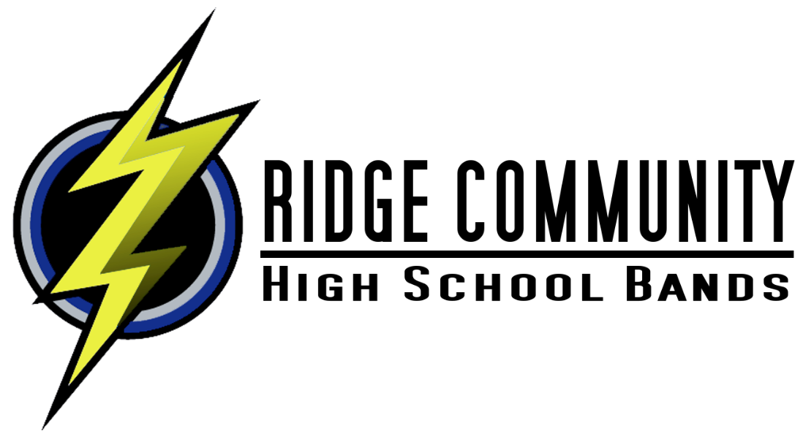
Come Out and Experience a High School Football Game and Perform in the stands with

Friday OCT 28^{th @} 6pm
Meet in the Ridge Community High School Band Room

If you have any questions, please contact
Mr. Vizoso at:
William.Vizoso@polk-fl.net
Or visit www.rchsbands.com

